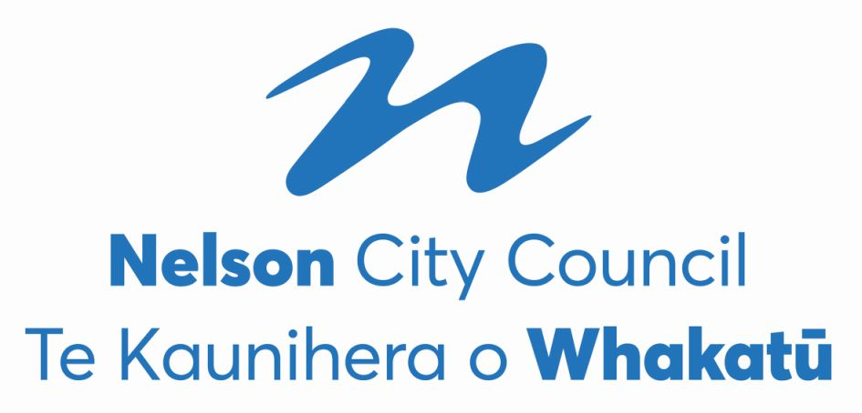
Nelson City Council
2022 Triennial Elections
PRELIMINARY RESULT
The voter return was 51.13%, being 20,082 voting papers, excluding special votes.
The preliminary result for the Nelson City Council elections held on Saturday 8th October is as follows.
Mayoralty
Nick Smith | Independent | Elected

Matt Lawrey |  | Excluded
Rohan O’Neill-Stevens |  | Excluded
Tim Skinner | Nelson Citizens Alliance | Excluded
Kerry Neal |  | Excluded
Richard Osmaston | Money Free Party New Zealand | Excluded
John Wakelin |  | Excluded

The final absolute majority of votes (final quota) as determined at the last iteration was 9,591. There were 31 informal votes and 96 blank votes.

Council - At Large (3 vacancies)
Rohan O’Neill-Stevens |  | Elected
Tim Skinner |  | Elected
Rachel Sanson |  | Elected

Ian Williams | Independent | Excluded
Zoe Byrne | Nelson Citizens Alliance | Excluded
Mike Ward |  | Exclluded
Mani Rai | Nelson Citizens Alliance | Excluded
Marie Lindaya | Whiria te tāngata Weave together | Excluded
Cindy Batt | Work 4 U | Excluded
Brent Pahl | Independent | Excluded
Margot Haley |  | Excluded

The final absolute majority of votes (final quota) as determined at the last iteration was 4,386.76. There were 325 informal votes and 1,004 blank votes.

Central Ward (4 vacancies)
Pete Rainey | Independent | Elected
Aaron Stallard | Independent | Elected
Matty Anderson | Independent | Elected
James Hodgson | Nelson Citizens Alliance | Elected

Peter Win | Nelson Citizens Alliance | Excluded
Cleo Cowdrey | Nelson Citizens Alliance | Excluded
Murray Cameron | Nelson Citizens Alliance | Excluded
Sean Davis |  | Excluded
Dai Mitchell | Independent | Excluded

The final absolute majority of votes (final quota) as determined at the last iteration was 1,595.49. There were 317 informal votes and 663 blank votes.

Stoke-Tāhunanui Ward (4 vacancies)
Mel Courtney | Independent | Elected
Campbell Rollo | Independent | Elected
Trudie Brand | Working For You | Elected
Matthew Benge |  | Elected

Ian Barker | Time to work better together | Excluded
Valmai Palatchie |  | Excluded
Harvey Ruru | Independent | Excluded
Allan Douglas Hoult | Nelson Citizens Alliance | Excluded
Mike Gane | Independent | Excluded
Harry Pearson | Nelson Citizens Alliance | Excluded
Sarah Minchington | Independent | Excluded
Rhys Bromell |  | Excluded
Lyndell Dodunski |  | Excluded

The final absolute majority of votes (final quota) as determined at the last iteration was 1,539.96. There were 268 informal votes and 513 blank votes.

Whakatū Māori Ward (1 vacancy)
Kahu Paki Paki |  | Elected

Bernie Goldsmith | Work 4 U | Excluded

The final absolute majority of votes (final quota) as determined at the last iteration was 171. There were 6 informal votes and 32 blank votes.

