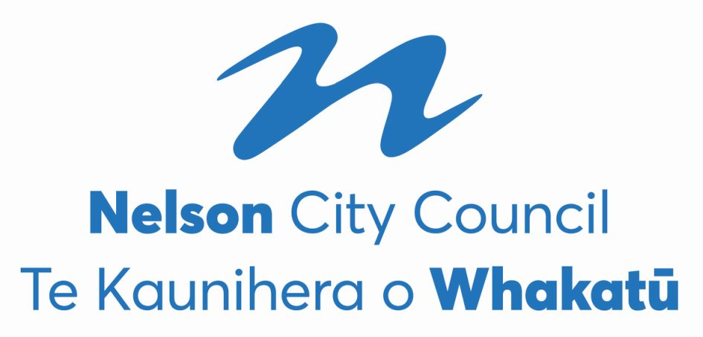
Nelson City Council
2022 Triennial Elections
PRELIMINARY RESULT

Mayoralty
Nick Smith | Independent | Elected

Matt Lawrey |  | Excluded
Rohan O’Neill-Stevens |  | Excluded
Tim Skinner | Nelson Citizens Alliance | Excluded
Kerry Neal |  | Excluded
Richard Osmaston | Money Free Party New Zealand | Excluded
John Wakelin |  | Excluded

The final absolute majority of votes (final quota) as determined at the last iteration was 8,492. There were 30 informal votes and 77 blank votes.
Council - At Large (3 vacancies)
Rohan O’Neill-Stevens |  | Elected
Tim Skinner |  | Elected
Rachel Sanson |  | Elected

Ian Williams | Independent | Excluded
Zoe Byrne | Nelson Citizens Alliance | Excluded
Mike Ward |  | Exclluded
Mani Rai | Nelson Citizens Alliance | Excluded
Marie Lindaya | Whiria te tāngata Weave together | Excluded
Cindy Batt | Work 4 U | Excluded
Brent Pahl | Independent | Excluded
Margot Haley |  | Excluded

The final absolute majority of votes (final quota) as determined at the last iteration was 3,872.96. There were 292 informal votes and 902 blank votes.
Central Ward (4 vacancies)
Pete Rainey | Independent | Elected
Aaron Stallard | Independent | Elected
Matty Anderson | Independent | Elected
James Hodgson | Nelson Citizens Alliance | Elected

Peter Win | Nelson Citizens Alliance | Excluded
Cleo Cowdrey | Nelson Citizens Alliance | Excluded
Murray Cameron | Nelson Citizens Alliance | Excluded
Sean Davis |  | Excluded
Dai Mitchell | Independent | Excluded

The final absolute majority of votes (final quota) as determined at the last iteration was 1,411.49. There were 282 informal votes and 591 blank votes.
Stoke-Tāhunanui Ward (4 vacancies)
Mel Courtney | Independent | Elected
Campbell Rollo | Independent | Elected
Trudie Brand | Working For You | Elected
Ian Barker | Time to work better together | Elected

Matthew Benge |  | Excluded
Harvey Ruru | Independent | Excluded
Allan Douglas Hoult | Nelson Citizens Alliance | Excluded
Valmai Palatchie |  | Excluded
Mike Gane | Independent | Excluded
Harry Pearson | Nelson Citizens Alliance | Excluded
Sarah Minchington | Independent | Excluded
Rhys Bromell |  | Excluded
Lyndell Dodunski |  | Excluded

The final absolute majority of votes (final quota) as determined at the last iteration was 1,366.52. There were 243 informal votes and 451 blank votes.

Whakatū Māori Ward (1 vacancy)
Kahu Paki Paki |  | Elected

Bernie Goldsmith | Work 4 U | Excluded

The final absolute majority of votes (final quota) as determined at the last iteration was 146. There were 6 informal votes and 31 blank votes.

