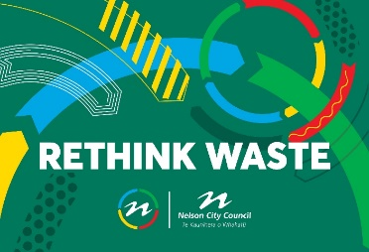
Council aims to avoid or reduce waste at events. The following are some guidelines and conditions for event organisers.

This document includes the following:
- Pre-event waste avoidance plan for event organisers
- Stallholder guidelines
- Event waste manager/staff or volunteer guidelines, including sourcing volunteers
- Engaging a waste service provider
- Links and resources

- PRE-EVENT PLANNING

Please complete the short waste avoidance plan so that this element can be built into your event plan at an early stage (an hour of free support is available from Council’s Environmental Programme Advisor – just email rethinkwaste@ncc.govt.nz. ).

Once your plan is complete you will be able to advise your vendors of what they need to do to comply with the plan, and identify what marketing messaging, signage, bins and personnel are required to deliver the best waste outcome. This will also be your working plan to use during and after the event.

EVENT WASTE MINIMISATION PLAN
How to use this plan:
Each time you would like to start a plan for a new event, please copy this document and complete the plan below. This document can then be used during and after your event to check activities and collection information on waste you have avoided.
- BEFORE THE EVENT
IDENTIFY EXPECTED TYPES AND QUANTITIES OF WASTE GENERATED BY THE EVENT:

Back of House (BOH - Includes setting up and packing down)
This could be cardboard boxes, cans, plastic wrap and containers etc. For larger events this area should be managed separately from your front of house area, because you will require bigger bins as the material will be bulky. You will also have better opportunities to educate vendors about recycling and composting systems.
You can choose to let food vendors use bin stations for their clean recycling and food scraps. But at most events vendors are asked to take their general waste with them.

BACK OF HOUSE WASTE STREAMS FROM FOOD AND BEVERAGE VENDORS:
Type | Estimated volume (wheelie bins or litres) | Suggested strategy to recover or recycle | Are you recovering or recycling the material? Y/N
Cardboard
Recyclable plastic 1, 2 & 5
Glass
Non recoverable waste (plastic wrap, un-recyclable plastic, etc
Other

Where you have indicated no, please explain what you are doing instead:

FRONT OF HOUSE (FOH) WASTE STREAMS FROM FOOD AND BEVERAGE VENDORS AND OTHER STAND HOLDERS:
Make it clear to stallholders when they register to attend your event they will need to comply with your Waste Minimisation and Management Plan.

Type | Estimated volume (wheelie bins or litres) | Suggested strategy to recover or recycle | Are you recovering or recycling the material? Y/N
Food scraps |  | Home compost
Home compostables  (fibre containers, wooden cutlery, paper straws, napkins) |  | Home Compost
Industrial compostables  (Coffee cups, clear PLA i.e smoothie cups, PLA lined containers) |  | Industrial compost
Aluminium |  | Recycling
Glass bottles |  | Recycling
Plastic bottles (plastics 1 & 2) |  | Recycling
Paper, cardboard (clean) |  | Recycling
Other

Where you have indicated no, please explain what you are doing instead:

ONCE PRE-EVENT WASTE ANALYSIS DONE, IDENTIFY KEY ACTIONS (example below):

Item (y/n) | Example Action | Action | Who? | When?
Vendor guidelines - y | Send guidelines to vendors
Wheelie bins - y | 10 required - get quote and book
Compost | Contact compost service provider to confirm what will be accepted and organise post event drop off
Signage - y | Signs for food scraps, compostables, recyclables and waste required for bins
Volunteers/staff - y | 8 volunteers in shifts including post event clean up. Identify who is responsible for briefing and overseeing volunteers.
Pre-event marketing - y | Include pack-in pack-out and bring your own cup messaging
Script for MC - y
Other

- ON THE DAY OF THE EVENT

CHECKLIST

❑ Waste minimisation stations set up with signage
❑ Vendors audited to check packaging complies with event plan
❑ Staff and volunteers briefed, including health & safety training
❑ MC briefed
❑ Other

AT END OF THE EVENT
CHECKLIST:

❑ Vendors have cleaned up their site as cleanly as possible and have met their agreed to requirements.
❑ Bin station staff/volunteers to collect any excess waste or waste packaging from all sites.
❑ All waste streams have been checked and sorted if needed to ensure they are ‘clean’, before transfer to resource recovery facility (recycling or composting).
❑ Make sure you collect data (see below) on waste diverted so you can tell the story and celebrate your success!

WASTE AUDIT:

Types of waste and waste collection. For each waste type calculate the total volume by using the volume of each bin multiplied by the number of full bins. Once you have recognised all types of waste and have a fair idea of quantities, please record them:

Type of waste | Type of bin | Total number of bins | Total Litres
Home Compost
Industrial Compost
Recycling – mixed cans, plastic and paper (or separate quantities – see below)
Recycling - cans
Recycling – plastics 1, 2 and 5
Recycling – cardboard and paper
General waste

APPENDIX ONE

STALLHOLDER ZERO WASTE EVENTS INFO (Compiled by Waste No More)

Thank you for being a part of this zero waste event! Even if you have participated in a zero waste event before please take the time to read this information, as requirements do change. ‘Zero Waste’ is about diverting as much landfill as possible, primarily to compost. To achieve this please ensure you only use packaging as listed below. We will check in with you at the start of the event to make sure we are all working to the same guidelines to achieve great zero waste results!

Event Organisers – please choose which of these items you will accept for your event and provide this information to your stallholders.

Yes/No  Home compostable: All serving items - utensils, cups, plates, serviettes etc must be compostable and fibre based. Please ensure all your items state that they are ‘home compostable’ (often things may look like paper but they have a plastic lining). Biodegradable or degradable are not the same as compostable, please avoid their use. Please hold onto the packaging so the compostability can be verified. | 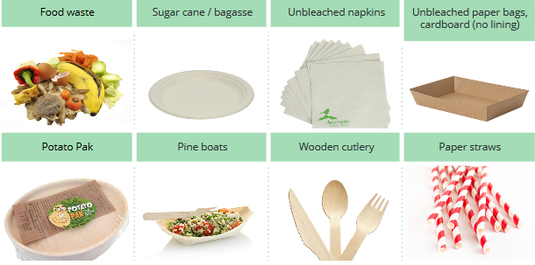
Yes/No  Recycling :  - Glass bottles  - Aluminium/ tin cans  - Plastics numbers 1, 2 & 5 only  - Paper and flat cardboard (please advise your vendors if you expect them to take their set up/pack down packaging away with them) | 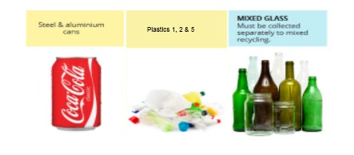
Yes/No

If you are planning to compost coffee cups please check the following information:

PLA lined compostable coffee/cold cups:

These look very similar to a standard paper coffee/cold cup, but have a PLA/plant based plastic lining, instead of regular plastic. The cups usually state that they are compostable. Here’s a list of accepted brands for the local composting plant - http://bit.ly/3bZDX6I Please use these types of cups (they come in different sizes) for ALL drinks/ smoothies/ milkshakes. PLA lids are accepted but please avoid using them if you can.

Yes/No  Industrial composting:  Some compostable items can only be composted in industrial facilities  No PLA/plant-based plastic: These items look similar to standard plastic but are made from plant starch, and need an industrial compost to break down. Although the region does have an industrial composting facility, PLA is highly problematic. Please avoid all PLA utensils, straws and use cup lids with discretion. Clear cups can be processed but should be a last resort. | 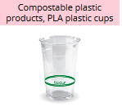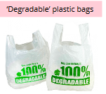
No plastic, including plastic containers, bottles, utensils, cups and lids, bags, cupcake syringes, polystyrene or glad wrap/cling film. These are not acceptable even if a vendor is offering to have them returned to reuse or recycle, nor for take home items. The issues are that many items still end up in landfill, they can’t be recycled as there’s too much food contamination, they cause extra work for the volunteers, and send a confused zero waste message. | 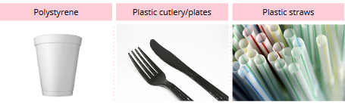  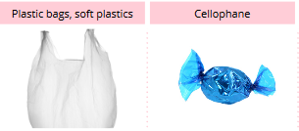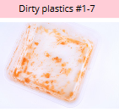
No aluminum foil or containers: They are in most cases too contaminated and can’t be recycled | 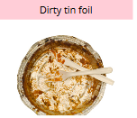
Other?

APPENDIX TWO

WASTE MANAGER, STAFF/ VOLUNTEERS GUIDELINES
Waste minimisation at events requires staff, whether voluntary or paid, for pre-planning and execution. You may wish to do the pre-planning yourself, or sub contract this out to your waste manager. Either way you’ll need waste staff on the day for the execution.

WASTE CHAMPION
Have someone in charge of waste logistics on the day. This person will:
- Set up & pack down your reusables system and/or bin stations
- Cover any permanent public rubbish bins if required
- Liaise with your chosen service provider for the different waste streams (recycling, waste, industrial compost, food scraps and home compostable items)
- Ensure you are collecting clean waste
- Troubleshoot with stallholders and making sure they are complying to the specifics of the day
- Manage staff/volunteers including briefing before the event. These should include:

  - How your reusables system will work (if applicable for your event)
  - Identifying packaging/waste as compostable, recyclable or landfill
  - Tips on interacting with the public in their role of ‘educating’ the public
  - Overview of health and safety (with induction delivered on event day)
  - What they should wear/bring on the day (hats, drink bottle, closed in shoes)
  - Ensure any personal protective equipment is given and explained to volunteers
  - Sign volunteers in and out.

STAFF/VOLUNTEERS

These people are the true heart of the mission. The ones informing and educating on the spot to the public that attends your event.
Their role is:
- Assist at your wash stations if you have a reusables system
- Monitor bin stations
- Litter pick the event site
- Assist with moving full bins/bags around the event site
- Assist with set up / pack down of your reusable system and/or waste stations
- Interact in a positive, supportive manner with event goers, helping them to place their items in the correct bin

HEALTH & SAFETY

Plan and deliver a good induction to all bin stations staff/ volunteers, including a sign in and out sheet. Be clear about all site specific risks, the evacuation and emergency procedures as well as the debrief for the specifics at bin stations for the event (presence of plastic instead of PLA, presence of plastic cutlery, etc).

RESOURCING VOLUNTEERS

You can either outsource the volunteers recruiting or do it yourself. If you choose to do it yourself you can:

- Approach individuals who are committed with waste minimisation
- Contact volunteer Nelson: https://www.facebook.com/Volunteernelson/
- Contact volunteer Nelson Youth: https://www.facebook.com/volunteernelsonyouth/
- Contact community groups to whom you would offer a lump sum to as a fundraising initiative. For example Nelson Brass band or a sports team.
- Advertise on your website how to attend the event by exchanging entry for a shift as a waste ambassador.

APPENDIX THREE

ENGAGING A WASTE SERVICE PROVIDER
The following companies hire & deliver wheelie bins & skips, and collect mixed recycling.
EnviroWaste also accepts some compostable waste - ask for specifics.

Provider | Contact | Area Serviced
CAN PLAN | canplan.co.nz  03 547 0642 | Nelson, Richmond, Brightwater &  Motueka
Nelmac /  Betta-Bins | nelmac.co.nz  service@nelmac.co.nz  0800 635 622 | 03 546 0910 | Nelson up to Teal Valley; Tasman  to Three Brothers Corner
Smart  Environmental | smartenvironmental.co.nz  thodgson@smartenvironmental.co.nz  0800 424 990 | 021 224 1280 | Nelson & Tasman (check for areas  covered)
Waste  Management | wastemanagement.co.nz  cfitzgerald@wastemanagement.co.nz  03 548 1166 | 027 442 8407 | Nelson, Motueka,  Wakefield
EnviroWaste | envirowaste.co.nz  steve.steele@envirowaste.co.nz  03 547 0662 | 027 523 8964 | Nelson & Tasman

COMPOST SERVICE PROVIDER

Community  Compost | communitycompost.co.nz  info@communitycompost.co.nz  027 777 7301 | Servicing Atawhai, Nelson,Stoke, Richmond  Hire 20L buckets with lids, or can  negotiate the type and size of vessel,  Collection of food waste & green waste.  Must be sorted to remove rubbish, plastic,  bioplastic, compostable packaging.  No packaging, meat, dairy, oils or eggs.
Green Waste to Zero | 18 Cargill Place, Richmond - Nelson  (03) 544 8857 | Bioplastic/PLA and compostable packaging with no to low grade food contamination.  A list of accepted PLA brands is here  bit.ly/3bZDX6Ibit.l

FULL WASTE MINIMISATION SERVICE PROVIDERS FOR EVENTS

WASTE NO MORE  NELSON WHAKATŪ | Phone 021 122 9439  Email contact.wastenomore@gmail.com  https://www.facebook.com/WasteNoMoreZerowaste/ | Servicing Nelson/Tasman  Full Event Waste Minimisation Provider.  Supply of signage and bins.  Consultations.  Wash Against Waste mobile wash station  See http://bit.ly/2SPbPf4

REUSABLE ITEMS PROVIDERS

Globelet | globelet.com  sales@globelet.com  022 133 2466 | Supply of reusable cups and systems to  events and festivals.
WASTE NO MORE  NELSON WHAKATŪ | Phone 021 122 9439  Email contact.wastenomore@gmail.com  https://www.facebook.com/WasteNoMoreZerowaste/ | Supply of reusable dishes and cups.  Wash Against Waste mobile wash station  See http://bit.ly/2SPbPf4
PARTY DEPOT | https://www.partydepot.nz/ | Huge selection of hire items including Plates, Glassware, Cutlery, Crockery, Catering Equipment, Party & Disco lighting, Festoon & Fairy lights

